Day 1: Objectives: Students will learn what greenware is and how to manipulate it. Students will learn what a test tile is and why it is used.

Greenware: Clay that has not been fired (heated to stone)
Test Tile: A small slab of clay that ceramic artists use to sample different decorating techniques.
Example  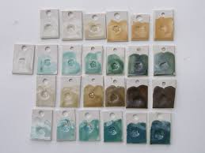 | Instructions:  Step 1: Create 3 Test Tiles Using soft clay. On one side of each tile carve your initials and the class period.  Step 2: Place one tile on a bat, one tile in a plastic bag, and one in a bucket of water.  Step 3: Write a prediction for what will happen to each tile by next class.

Open Air | Plastic Bag | Water

Day 2: Objectives: Learn how greenware reacts to different environments and why it's important. Learn basic ceramic related vocabulary
Step 1: When you come back to class find your 3 tiles. Write your observations on what actually happened to the tiles.

Bat | Bag | Water

Step 2: Write down the definitions for the following terms as they are discussed.
Greenware:

Slip:

Plastic:

Leatherhard:

Bone Dry:

Kiln:

Bisqueware:

Glaze:

Glazeware:

Step 3: Follow Mr. Z’s instructions for Decorating test tiles. Describe observations before and after firing in the table below. (Second Test Tile Optional)
Test Tile 1 | Appearance Before Firing | Appearance After Firing
Glaze 1:

Glaze 2:
Glaze Overlap:

Test Tile 2 | Appearance Before Firing | Appearance After Firing
Engobe(s):

